Q.1. Create an Array with five names and print all five in reverse.

CODE:-

<html>

<head>

<title> Javascript Array reverse Method</title>

</head>

<body>

<script type = "text/javascript">

var arr ["manisha","pooja","nihal","nikhil","kunal"].reverse();

document.write("Reversed array is : " + arr);

</script>

</body>

</html>

OUTPUT:-

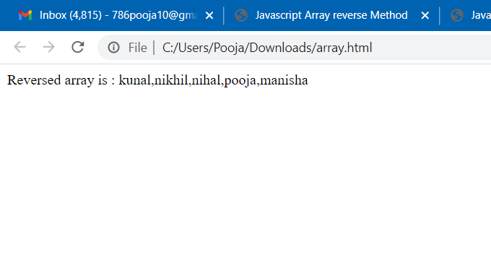

Q.2. Print only the elements which are divisible by 5 from 1 to 50.

CODE:-

<script>

//Javascript program to print all the numbers

// divisible by 5 or 7 for a given number

// Result function with N

function NumGen (n)

{

// iterate from 0 to N

for (let j = 1; j < n + 1; j++)

{

// Short-circuit operator is used

if (j % 5 == 0 || j % 7 == 0)

document.write(j + " ");

}

return n;

}

// Driver code

// Input goes here

let N = 50;

// Iterating over generator function

NumGen (N);

</script>

OUTPUT:-

